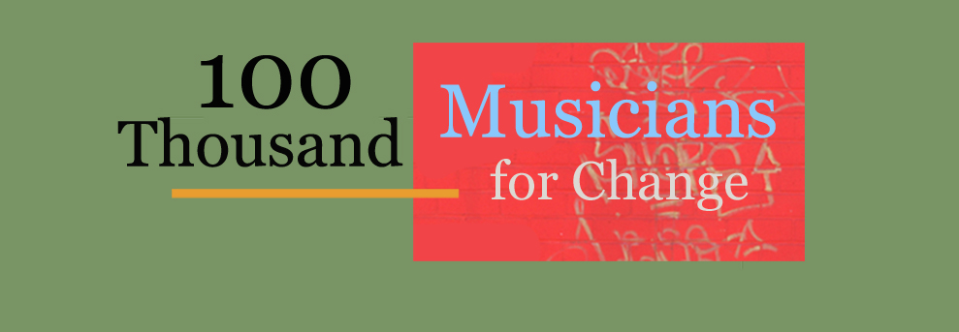
This year’s Global Event - September 28^{th,} 2013!

Musicians around the world are planning individual events to take place simultaneously on September 28th in conjunction with 100 Thousand Poets for Change in a demonstration/celebration of poetry, art and music to promote social, environmental, and political change.
So far, 100’s of cities representing over 100 countries have signed up making the 100 TPC global initiative a success through poetry readings, concerts, public demonstrations, festivals, community awareness events, parades, and more!
Do you want to participate in an event?
Do you want to organize something in your area?
Do you want to learn more about all the 100 TPC Events?
Visit www.100TPC.org
for complete details about
100 Thousand Musicians for Change

Write us at walterblue@bigbridge.org if you are interested in organizing or being a part of this global event!
Join Us!

